**Lab 4**

Start PICSimLab. Select the board McLab2. Select PIC16F877A as microcontroller using the micro-controller tab. Configure the microcontroller through your code as follows:

#pragma config FOSC = XT // Oscillator Selection bits (XT oscillator)

#pragma config WDTE = OFF // Watchdog Timer Enable bit (WDT disabled)

#pragma config PWRTE = OFF // Power-up Timer Enable bit (PWRT disabled)

#pragma config BOREN = OFF // Brown-out Reset Enable bit (BOR disabled)

#pragma config LVP = OFF // Low-Voltage (Single-Supply) In-Circuit Serial Programming Enable bit (RB3 is digital I/O, HV on MCLR must be used for programming)

#pragma config CPD = OFF // Data EEPROM Memory Code Protection bit (Data EEPROM code protection off)

#pragma config WRT = OFF // Flash Program Memory Write Enable bits (Write protection off; all program memory may be written to by EECON control)

#pragma config CP = OFF // Flash Program Memory Code Protection bit (Code protection off)

Program the microcontroller so that one-digit decimal number on the right-most display is

* incremented every 0.2 second if S3 is continuously pressed.
* decremented every 0.2 second if S4 is continuously pressed.
* not changed if none of the switches is pressed as shown in Solution_Video.

The number shown on the display will be 0(zero) when 9 is incremented. Similarly, the number shown will be 9 when 0(zero) is decremented as shown in Solution_Video_2.

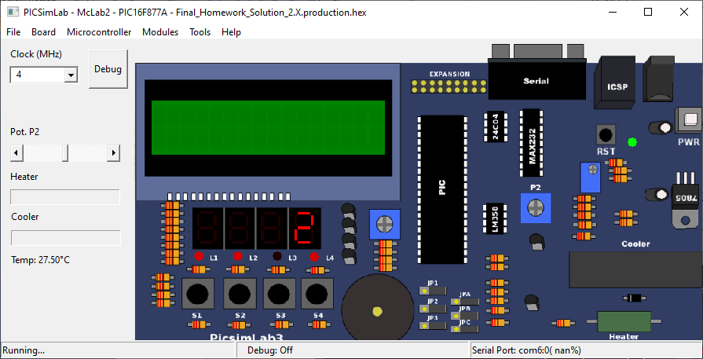

**Figure 1.** Use of right-most display to show the number incremented every 0.2 seconds.

**Important Note 1:** Set the prescaler for TIMER0 to 1:128 using OPTION_REG register. You are not allowed to use any other prescaler value for this task. Set the clock frequency to 4 MHz.

**Important Note 2:** This task will be implemented in C programming language (-100 pts otherwise).

Create a video which displays:

1. you used timer interrupt in the code, (10 points, -100 pts otherwise)
2. you set the prescaler to 1:128, (10 points, -100 pts otherwise)
3. the code is successfully built (compiled), (10 points)
4. the HEX output is loaded onto PICSimLab, (10 points)
5. you selected 4 MHz clock, (10 points, -100 pts otherwise)
6. the board works as described in this manual. (50 points)

The video should include your video in the upright position and your voice while you are performing and explaining the above actions (-100 points otherwise). There is no need to explain the code in the video.

The video filename and source code filename should be named as follows:

Microprocessors_Lab_4_StudentNumber_Name_Surname.mp4

Microprocessors_Lab_4_StudentNumber_Name_Surname.c

*Example:*

*Microprocessors_Lab_4_69284571_Mehmet_Kocaturk.mp4*

*Microprocessors_Lab_4_69284571_Mehmet_Kocaturk.c*

Please only upload the video file and .c file into Microsoft Teams assignment.